Central Mississippi
Buddy Walk® & 5K
Saturday, October 13, 2018
Trustmark Park
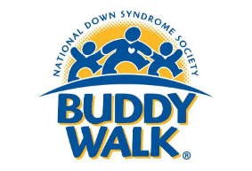

Sponsorship Proposal

What is the Buddy Walk®?
The Buddy Walk® was developed by the National Down Syndrome Society (NDSS) in 1995 to celebrate Down Syndrome Awareness Month in October and to promote acceptance and inclusion of people with Down syndrome. The Buddy Walk® has grown from 17 walks in 1995 to nearly 300 walks today. Each year, more than $12 million is raised across the country and around the world to support local programs and services, as well as national advocacy and public awareness initiatives of NDSS that benefit all individuals with Down syndrome.

What is the mission of the Central Mississippi Down Syndrome Society?
The mission of CMDSS is to provide support, education and advocacy for people with Down syndrome, their families and communities across Central Mississippi. Our vision is for a community where people with Down syndrome have limitless opportunities and the ability to pursue their dreams.

How does the event work?
Packet Pick-Up and On-Site Registration for the CMDSS Buddy Walk 5K + Fun Run will be held from 7:00 – 8:00 am. At 8:30 am the 5K begins. The Kid’s Fun Run begins at 9:30 am. Packet Pick-Up and On-Site Registration for the Buddy Walk opens at 9:00 am. At 10:00 am, 5K Awards will be given. Immediately following awards, the Buddy Walk opening ceremony will begin, followed by the Walk Celebration. Throughout the Buddy Walk, participants will have the opportunity to visit Info Alley, grab a bite to eat, shop the diverse items in the silent auction, hang out in Entertainment Alley for face painting, temporary tattoos, games and much more.
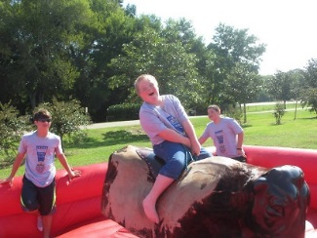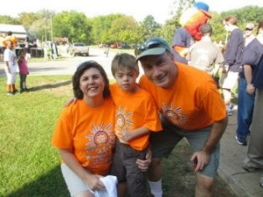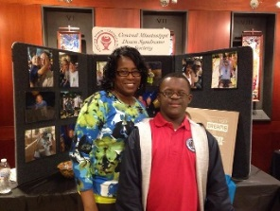
2018 Dates to Remember
April 15:
Early-Bird registration opens
September 15:
Last day for online registration to be guaranteed a t-shirt
Last day to turn in donations to be eligible for team incentives
October 13:
2018 Central Mississippi Buddy Walk
Sponsorship Opportunities

The mission of the Central Mississippi Down Syndrome Society is made possible by the funds raised at the Buddy Walk. It is through the generous support of our sponsors, our walkers, and our community that we are able to provide support, programs, and education to individuals with Down syndrome and their families in the Central MS region. In recognition of your support, we plan to highlight your organization as outlined below:

Presenting Sponsor $5000 (up to 2)
- Opportunity for a company leader to be a part of the kick-off presentation
- Booth space to promote products and services
- Your organization’s logo on the Jumbo Tron, event signage and the route of the Walk
- Lead recognition on media releases, social media and all event promotions
- Large logo on event t-shirts prominently displayed (~1000)
- Logo on the 2019 CMDSS Calendar (1500 printed)
- Complimentary (Walk or Run) registrations for your organization
Gold Sponsor $2500
- Booth space to promote products and services
- Your organization’s logo on the Jumbo Tron, event signage and the route of the Walk
- Recognition on media releases, social media and all event promotions
- Logo on event t-shirts prominently displayed (~1000)
- Name on the 2019 CMDSS Calendar (1500 printed)
- Complimentary (Walk or Run) registrations for your organization
Silver Sponsor $1000
- Booth space to promote products and services
- Your organization’s logo on the Jumbo Tron, event signage and the route of the Walk
- Recognition on social media and event promotions
- Logo on event t-shirts (~1000)
- Name on the 2019 CMDSS Calendar (1500 printed)
- Complimentary (Walk or Run) registrations for your organization
Bronze Sponsor $500
- Booth space to promote products and services
- Your organization’s logo on the Jumbo Tron, event signage and the route of the Walk
- Recognition on social media and event promotions
- Logo on event t-shirts (~1000)
Friends of CMDSS $100-$499
- Your organization’s logo on the Jumbo Tron, event signage and the route of the Walk
- Recognition on social media and event promotions
- Name of organization on event t-shirts (~1000)

Commitment Form
Name of Organization: _________________________________________________
Contact Name and Title: _______________________________________________
Email: ______________________________ Phone: ____________________
Address: ____________________________________________________________
If your sponsorship is being made in honor of a particular Buddy (individual with Down syndrome), please list the name: ___________________________________
Please mark the desired sponsorship level:
- Presenting ($5000)
- Gold ($2500)
- Silver ($1000)
- Bronze ($500)
- Friends of CMDSS ($100-$499)

T-shirt Sizes (select 2) S _____ M_____ L_____ XL _____ XXL_____
Would your organization like a table (includes 2 chairs) at the event? Y ___ N ___

Please make checks payable to “CMDSS Buddy Walk.” Mail your payment and this page to:

CMDSS
Attn: Buddy Walk
P.O. Box 935
Jackson, MS 39205

*Please email your logo (if applicable) in a vector format to buddywalk@cmdss.org prior to Sept 1.

To request an invoice please email Jennifer Babl at Jenny@cmdss.org. To pay with a credit card or bank account, access our PayPal account at donations@cmdss.org.

Please remember that all commitments need to be confirmed with the event coordinator by September 1 for inclusion on the event shirts and signage. We will work to accommodate sponsors who commit after that date with social media and other recognitions as allowed.

