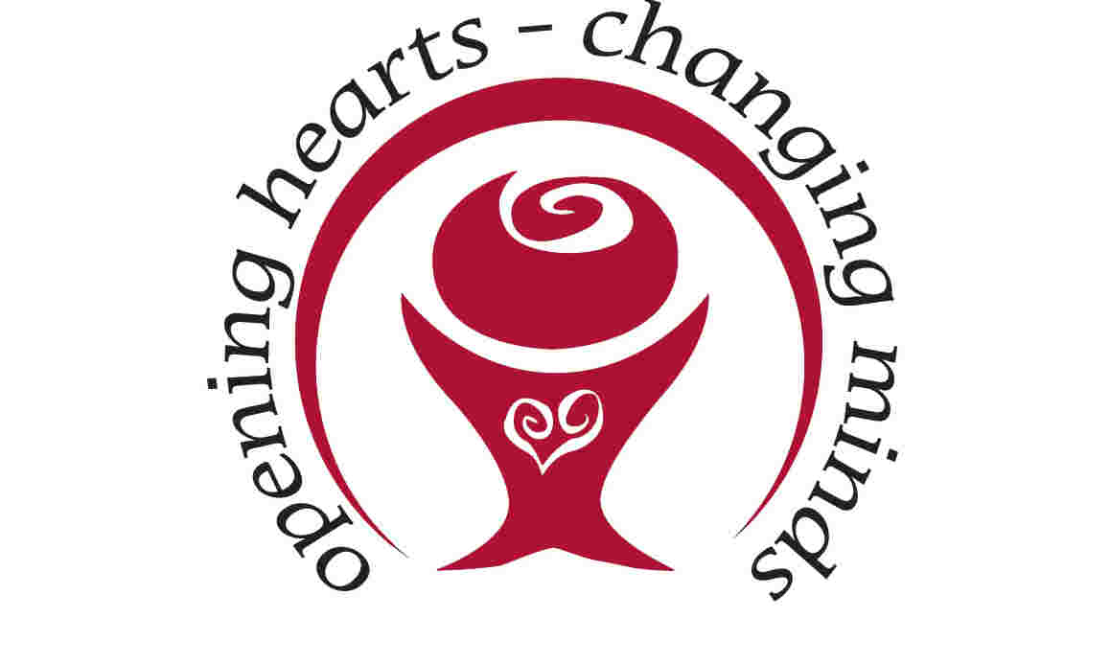

Central Mississippi Down Syndrome Society
17th Annual Buddy Walk®
& Fun Run
Saturday, October 12, 2019
Trustmark Park
Pearl, MS

Sponsorship Proposal

What is the Buddy Walk®?
The Buddy Walk® was developed by the National Down Syndrome Society (NDSS) in 1995 to celebrate Down Syndrome Awareness Month in October and to promote acceptance and inclusion of people with Down syndrome. The Buddy Walk® has grown from 17 walks in 1995 to nearly 300 walks today. Each year, more than $12 million is raised across the country and around the world to support local programs and services, as well as national advocacy and public awareness initiatives of NDSS that benefit all individuals with Down syndrome.

What is the mission of the Central Mississippi Down Syndrome Society?
The mission of CMDSS is to provide support, education and advocacy for people with Down syndrome, their families and communities across Central Mississippi. Our vision is for a community where people with Down syndrome have limitless opportunities and the ability to pursue their dreams.

How does the Buddy Walk & Fun Run work?
Packet Pick-Up will be Friday, October 11 from 12 – 5pm outside of Trustmark Park.
Packet Pick-Up and On-Site Registration for the CMDSS Buddy Walk & Fun Run will be held from 8:00 – 9:00 am. At 9:30 am the Fun Run begins. Packet Pick-Up and On-Site Registration for the Buddy Walk opens at 9:00 am. At 10:00 am, Fun Run Awards will be given. Immediately following awards, the Buddy Walk opening ceremony will begin, followed by the Walk Celebration. Throughout the Buddy Walk, participants will have the opportunity to shop our large silent auction, visit Info Alley, grab a bite to eat, hang out in Entertainment Alley for face painting, games and much more.
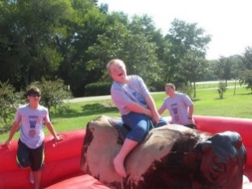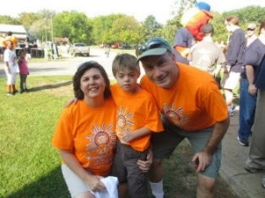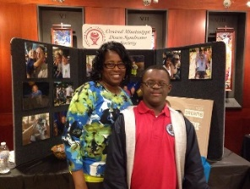
2019 Dates to Remember
April 30:
Registration opens
September 1:
Sponsorship Forms Due
September 15:
Last day for online registration to be guaranteed a t-shirt
Last day to turn in donations to be eligible for team incentives
Sponsorship Opportunities

The mission of the Central Mississippi Down Syndrome Society is made possible by the funds raised at the Buddy Walk. It is through the generous support of our sponsors, our walkers, and our community that we are able to provide support, programs, and education to individuals with Down syndrome and their families in the Central MS region. In recognition of your support, we plan to highlight your organization as outlined below:

Presenting Sponsor $10000 (up to 2)
- Opportunity for a company leader to be a part of the kick-off presentation
- Table top space to promote products and services
- Your organization’s logo on the Jumbo Tron, event signage and the route of the Walk
- Lead recognition on media releases, social media and all event promotions
- Large logo on event t-shirts prominently displayed (~1500)
- Logo on the 2020 CMDSS Calendar (1500 printed)
Platinum Sponsor $5000
- Table top space to promote products and services
- Your organization’s logo on the Jumbo Tron, event signage and the route of the Walk
- Recognition on media releases, social media and all event promotions
- Logo on event t-shirts prominently displayed (~1500)
Gold Sponsor $2500
- Table top space to promote products and services
- Your organization’s logo on the Jumbo Tron, event signage and the route of the Walk
- Recognition on social media and event promotions
- Logo on event t-shirts (~1500)
Silver Sponsor $1000
- Table top space to promote products and services
- Your organization’s logo on the Jumbo Tron, event signage and the route of the Walk
- Recognition on social media and event promotions
- Logo on event t-shirts (~1500)

Bronze Sponsor $500
- Table top space to promote products and services
- Your organization’s name on the Jumbo Tron, event signage and the route of the Walk
- Recognition on social media and event promotions
- Name of organization on event t-shirts (~1500)
Friend of CMDSS $250 – $499
- Your organization’s name on the Jumbo Tron, event signage and the route of the Walk
- Recognition on social media and event promotions
- Name of organization on event t-shirts (~1500)
Silent Auction Item
The Buddy Walk includes a large silent auction shopping event and we invite you to donate one or more items. Please note that the value of the silent auction item does not count toward sponsorship level of commitment.
Please provide a brief description of the item(s) you are donating: ___________________________________________________________________________ ___________________________________________________________________________
___________________________________________________________________________
Approximate retail value: $___________________
_____ Please select if you would like CMDSS to pick up your donation item and include a contact name and email below.
Contact Name: _____________________________
Contact Email: _____________________________
Phone: ___________________________________

Buddy Walk Commitment Form

Name of Organization: _____________________________________________________
Contact Name and Title: ____________________________________________________
Email: ___________________________________ Phone: _________________________
Address: _________________________________________________________________
If your sponsorship is being made in honor a particular Buddy (individual with Down syndrome), please list their name: ____________________________________________
Please mark the desired sponsorship level:
- Corporate ($20000-$30000)
- Presenting ($7500)
- Platinum ($5000)
- Gold ($2500)
- Silver ($1000)
- Bronze ($500)
- Friend of CMDSS ($250-$499)
- Silent Auction Item (variable)

Please make checks payable to “CMDSS Buddy Walk.” Mail your payment and this page to:

CMDSS
Attn: Buddy Walk
P.O. Box 935
Jackson, MS 39205

To request an invoice, please email Jennifer Babl at Jenny@cmdss.org. To pay with a credit card or bank account, access our PayPal account at donations@cmdss.org.

Please remember that all commitments need to confirm with the event coordinator by September 1 for inclusion on the event shirts and signage. We will work to accommodate sponsors who commit after that date with social media and other recognitions as allowed.

